Parent Communication: Reflecting Ongoing Learning in Grades 7-9

Beginning September 2018 in HRCE, reporting terms in grades P-9 will shift from being separate terms to continuous terms. This will align with the ongoing nature of student learning, the ongoing development of skills students use when they learn (communication, critical thinking, problem solving, etc.), and the method of reporting in grades 10-12.

Traditionally in P-9 teachers have reported on student progress at the end of each term (November, March and June) considering only the evidence of student learning gathered within that term. With continuous terms, reporting will now be a pause and reflect to summarize learning to date since September, based on trends over time and more recent evidence of student learning.

**Previously:** Three discrete terms with a summary report of *each individual term*.

                                        Term 1 Term 2 Term 3

Report Card Report Card Report Card

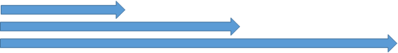**New Model:** Continuous terms with pause and reflect reporting to date.

            Term 1 Report Card

                                                              Term 2 Report Card

                      Term 3 Report Card

* **Structure of the Report Card**: looks exactly the same
* **Report Card Comments**: continue to reflect strengths, areas for improvement and suggestions for next steps
* **Report Card Grades**: now reflect *learning to date* since September.
  + **Term 1**- no change from previous, based on evidence of learning from September to November.
  + **Term 2**- based on evidence of learning from September to March
  + **Term 3**- based on evidence of learning from September to June; now reflects overall achievement for the course