Fundraising Initiative
As a fundraising initiative Caledonia Junior High School will be selling wooden tree ornaments. These handcrafted ornaments will feature the Caledonia Junior High school logo (see photo below). The ornaments will sell for $15.00 with $5.00 from each ornament going directly back to the school. The profit from this initiative will go to support increased flexible seating in our classrooms.
The selling period will run from November 4th to November 18th. Money is payable to the school and must be returned with the orders by November 18th.
Please use the attached order form to keep track of your orders. Ornaments will be ready to be sent home no later than December 13th.
If you have any questions about this fundraiser, please feel free to contact the school office at (902)435-8413. Thank you so much for your support!
Caledonia Junior High School

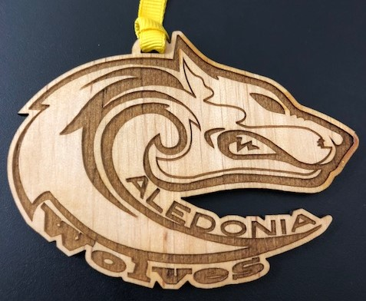

Caledonia Junior High School Ornament Order Form
Customer Name | Telephone | # of Ornaments | Money Collected
Name___________________________ Homeroom________________________

