August 26th 2020
Back to School Update: Masks/No Sharing/ Hand Sanitizing/Daily COVID Screening Tool

We are excited to update families that today, HRCE delivered masks for each student and staff, hand sanitizer and signage to support our back to school plan. We will continue to provide updates around all topics related to returning to school. We will be communicating regularly to answer the many questions families are thinking about.
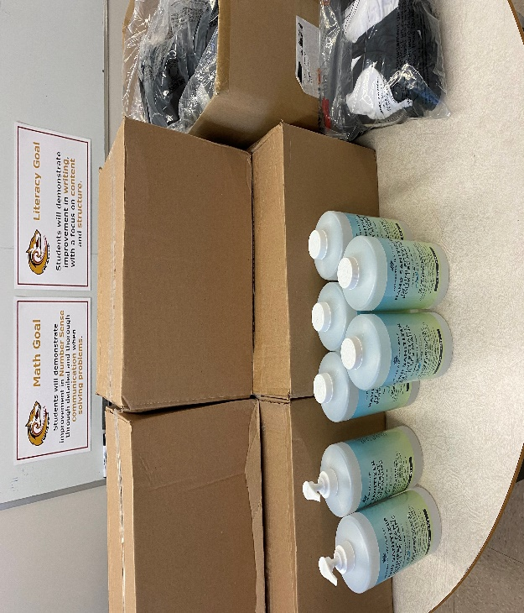
Masks:
Staff and students will be provided with two reusable masks. Later this week we will send a google sign-up sheet via email for families who would like to book an appointment to receive their masks ahead of school opening. Public libraries are offering free masks to families as well. Non- Medical masks that will be provided is one component of the back to school plan. Non-medical masks provides an added level of protection when other health measures, such as proper hand washing/ hand sanitizing are in place. To help students prepare for the transition back to school families can go over safe mask wearing and handwashing/sanitizing methods. I have enclosed examples for families to share with students. Students will start their day with a mask on if they travel on a bus and as they enter school property if they are walking. Students will meet their homeroom teacher and be cohorted (homeroom class) as soon as they arrive. Each class with their homeroom teacher (one class at a time) will go into the building and as they enter, the building they will use/visit the hand sanitizing station.
All students in grade 4-12 will be required to wear a mask if they cannot physically distance from others, even when they are in the classroom with their cohorts. That is, students in grade 4-12 will wear a mask unless they are:
- Seated in the classroom at a distance of 2 m/ 6 feet from others facing in the same direction.
- Eating or drinking

Hand Sanitizing Stations:
Hand sanitizing stations are located just inside each doorway (per grade level). Grade 7 students will only use the front door, Grade 8 students will only use the back door around the back of the building and Grade 9 students will only use the side door near the Beazley Park. More sanitizing stations are set up outside every classroom. Students will be required to hand sanitize as they enter the building and their classroom and throughout the day. Enhanced cleaning of desks, washrooms and high traffic areas will be done throughout the day.
No Sharing:
As per the back to school plan students will remain with their cohort (homeroom) and are reminded sharing is not caring during a pandemic. (Pencils, food, books, etc.) Students will be using their own supplies that they bring to school in am and take home each night. Any items such as chrome books, math manipulative, text books that are used by more than one student throughout the day will be cleaned before and after each students use.
Daily COVID Screening Tool
We have attached the Nova Scotia Daily COVID Screening tool to use with your child each day before going to school.

