CALEDONIA SPIRIT DAYS!!!
Monday December 13 | Holiday Sweater day  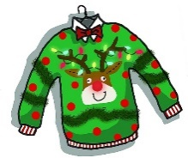
Tuesday December 14 | Dress like your favorite snowman
Wednesday December 15 | Dress in holiday colors
Thursday December 16 | Wear a holiday hat, Bonnets, socks, etc  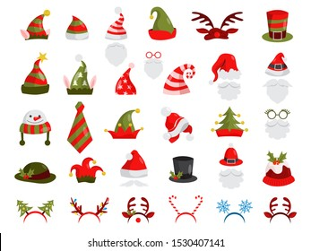
Friday December 17 | T’was the night before the weekend…. PJ day!!  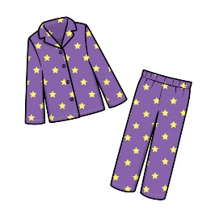

Monday December 20 | Grinchy Monday- wear green  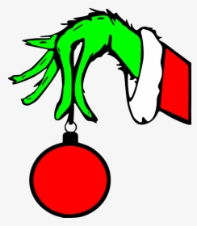
Tuesday December 21 | Its tinsel, tassel and bedazzle….Cal Pride day!!!  