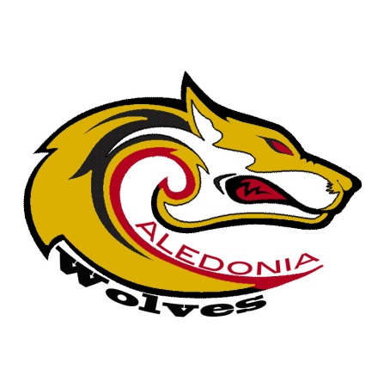
Caledonia Junior High School
38 Caledonia Road, Dartmouth, NS B2X 1K8
Telephone: 435-8413 Fax: 435-8425
Principal: Ms. L. Vaughan
Vice Principal: Mr. G. Miller
www.caledonia.ednet.ns.ca

Dear Parents and Guardians,

Welcome to another year of Getting to Great, Halifax Regional School Board’s school improvement survey. The purpose of this letter is to provide you with some details and information on why completion of this survey is so important to the student success within our board.

The Getting to Great survey provides an opportunity for students in grades 4-12, all parents/guardians, all teachers, and support staff to share information that will help us improve schools. Your voluntary participation in this survey will help us to identify the strengths and areas for growth at our school. This will enable us to enhance the opportunities we provide for students to learn. Your input is valuable in helping us make improvements that will directly impact your child’s learning and school experience.

The online survey is available from April 4th- 29th 2016. Please visit the website: http://survey.hrsb.ns.ca and select Caledonia Junior High to start the survey. You are welcome to complete a survey for each of your children attending our school. Please remember, all survey information is anonymous and is not used to evaluate individuals. At the end of the survey, you will find space to make any additional comments you wish to share with us anonymously.

Thank you for your participation; your input is very important to us!
Sincerely,
Lisa Vaughan

