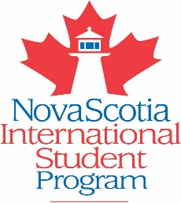

HOST AN INTERNATIONAL STUDENT

The Nova Scotia International Student Program brings students from around the world to Nova Scotia public schools to learn our language and culture. Be an integral part of a student’s learning experience– become a host family.

This is a great opportunity for your family to experience and share culture first hand. Your family will be matched up with a student and they will participate in your daily family routines.
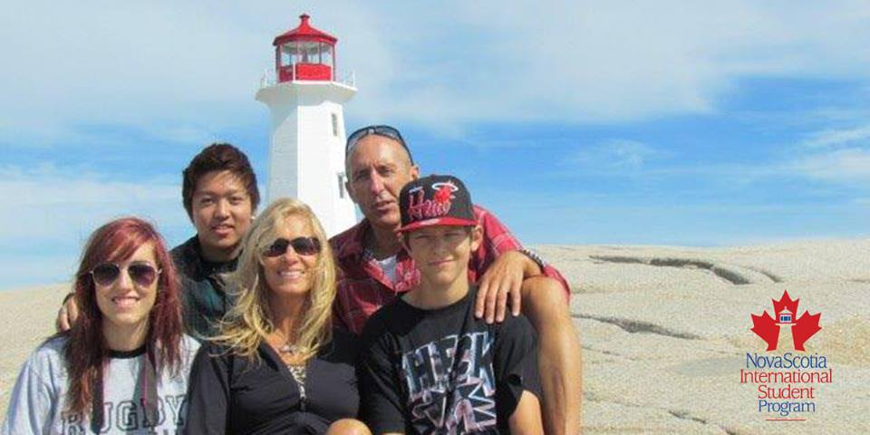
Host Families receive a tax free monthly stipend to help
cover the cost of food and any extra transportation expense
Students stay for periods of 2 to 10 months
Ongoing support is provided by an experienced Homestay
Coordinator
You will learn about and communicate with your student
before arrival
Host Families are asked to provide a private bedroom, 3
balanced meals a day and inclusion in family activities

Visit our website for more information: www.nsisp.ca

For more information on how to become a host family
for an international student in the Halifax Regional School Board please contact:

Marilyn Hurst at mhurst@hrsb.ns.ca or at 902 464-2000 Ext. 2548

