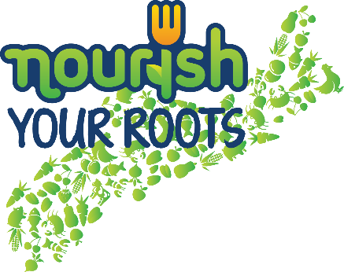

We are taking part in Nourish Nova Scotia’s “Nourish Your Roots”
fundraiser to support healthy food programs and activities at our school.

You can support our students and local farmers by selling/buying boxes of fresh produce from TapRoot Farms in partnership with Noggins Corner Farm Market, Spurr Brothers Farms, Sawler Gardens and Nova Agri.

Selling for $30, the boxes represent good value. Each farm box will include a variety of seasonal fresh produce such as carrots, potatoes, turnip, and depending on the farm / availability, a selection from apples, beets, Brussels sprouts, cabbage, cranberries, kale, leeks, onions, parsnips, pears, sweet potatoes and squash with a focus on root vegetables.

The selling period is between 14th and 25th November. All orders/money must be returned to the school by November 25th 2016

Students use the envelope provided to track order names and collect money. The information handout acts as a receipt, it is very important that the date, time and location that the customer must pick up their box is filled in. Some students may need assistance completing this information. For our school the farm box pick-up will take place on December 9th, between 1-3:30 PM at Side Door near the Basketball Court (In the event of a winter storm that closes schools pick up will take place December 12th, between 1-3:30 PM at Side Door near the Basketball Court). Please check-in at the main entrance when you arrive; and then drive around to the side for pick-up.

For additional information about this fundraiser check out nourishns.ca/nourish-your-roots

